Indian Handicrafts Industry

India is one of the important suppliers of handicrafts to the world market. The Indian handicrafts industry is highly labour intensive cottage based industry and decentralized, being spread all over the country in rural and urban areas. Numerous artisans are engaged in crafts work on part-time basis. The industry provides employment to over six million artisans (including those in carpet trade), which include a large number of women and people belonging to the weaker sections of the society.

In addition to the high potential for employment, the sector is economically important from the point of low capital investment, high ratio of value addition, and high potential for export and foreign exchange earnings for the country. The export earnings from Indian handicrafts industry for the period 1998-99 amounted to US$ 1.2 billion.

Although exports of handicrafts appear to be sizeable, India’s share in world imports is miniscule. It is a sector that is still not completely explored from the point of view of hidden potential areas. India, a country with 26 states and 18 languages and more than 1500 dialects offers an enormous range of handicrafts from each of the states. Major centres in Uttar Pradesh are Moradabad also known as the "Peetalnagari" (City of Brass), Saharanpur for its wooden articles, Ferozabad for Glass. The North Western state of Rajasthan has to offer the famous Jaipuri quilts, Bagru and Sanganer printed textiles and wooden and wrought iron furniture from Jodhpur. The coastal state of Gujarat comes with embroidered articles from Kutch. Narsapur in Andhra Pradesh is famous for its Lace and Lace goods. But this is only a small part of the total product range. India offers much more.

Handicrafts are classified into two categories:

- Articles of everyday use
- Decorative items

The craftsmen use different media to express their originality. The diversity of the handicrafts is expressed on textiles, metals – precious and semi-precious, wood, precious and semi-precious stones, ceramic and glass.

Textile based handicrafts:
Hand printed textiles including block and screen printing, batik, kalamkari (hand printing by pen) and bandhani (tie and die) are used in products ranging from bed-covers to sheets, dress material to upholstery and tapestry. The famous embroidered articles of silk and cotton, often embellished with mirrors, shells, beads, and metallic pieces are also found in India. Embroidery is done too on leather, felt and velvet etc. This segment of the industry accounts for almost half a million strong employment in addition to a large number of designers, block makers, weavers and packers involved in the trade.

Clay, Metal and Jewellery:
Brass, copper, bronze, bell metal are used for a variety of wares and in a variety of finishes. Scintillating ornaments are available in a wide range of patterns, styles and compositions. Made from precious metals, base metals, precious and semi-precious stones; these ornaments have traditional as well as modern styles.

Woodwork:
Wooden articles in India range from the ornately carved to the absolutely simple. One can find toys, furniture, decorative articles, etc. bearing the art and individuality of the craftsman. India is known particularly for its lacquered wood articles.

Stone Craft:
The intricately carved stoneware made of marble, alabaster or soapstone, etc., inlaid with semiprecious stones carry on the heritage of Indian stone crafts.

Glass and Ceramic:
Glass and ceramic products are a fast upcoming segment in the handicrafts from India. The age-old production process of mouth-blowing the glass instills a nostalgic feeling. The varied shapes of ceramic and glass in a number of colours, would appeal to Western aesthetics while retaining the Indian touch.

Craft concentration Areas:

A wide range of handicrafts are produced all over Indian artmetalware / EPNS ware, wood carvings and other wooden artwares, imitation jewellery, handprinted textiles, shawls as artwares, embroidered goods, lace and lace goods, toys, dolls, crafts made of leather, lacquerware, marble crafts etc. Although it is difficult to limit a specific place for the particular craft, the following places are listed for their particular crafts.

Artmetalware | : | Moradabad, Sambhal, Aligarh, Jodhpur, Jaipur, Delhi, Rewari, Thanjavur, Madras, Mandap, Beedar, Kerala & Jagadhari, Jaselmer
Wooden Artwares | : | Saharanpur, Nagina, Hoshiarpor, Srinagar, Amritsar, Jaipur, Jodhpur, Jagdalpur, Bangalore, Mysore, Chennapatna, Madras, Kerala & Behrampur (WB)
Handprinted Textiles & Scarves | : | Amroha, Jodhpur, Jaipur, Farrukhabad, Sagru & Sanganer
Embroidered goods | : | Kutch (Gujarat), Jaisaimer, Baroda, Lucknow, Jodhpur, Agra, Amritsar, Kullu, Dharmshala / Chamba & Srinagar
Marble & Soft Stone Crafts | : | Agra, Madras, Baster, Jodhpur
Papier Mache Crafts | : | Kashmir, Jaipur
Terracotta | : | Agra, Madras, Baster, Jodhpur
Zari & Zari Goods | : | Rajasthan, Madras, Baster
Imitation Jewellery: | : | Delhi, Moradabad, Sambhal, Jaipur, Kohima (Tribal)
Artistic Leather Goods | : | lndore, Kolhapur, Shanti Niketan (WB)

Selected crafts pockets for achieving export goal:

Although each crafts pockets has its particular problems, a few selected craft pockets are identified based on their past performance for immediate remedial attention to stimulate a quantum in exports of handicrafts in the coming years.

Moradabad(UP) | : | For Artmetalwares and imitation jewellery
Saharanpur (UP) | : | For Wooden handicrafts & Wrought iron handicrafts
Jodhpur (Raj.) | : | For Wooden, Wrought Iron and Sea Shell handicrafts
Narsapur (A.P.) | : | For Lace and Lace goods

COUNTRY-WISE EXPORTS OF HANDICRAFTS

The major buyers for handicrafts (other than carpets) are as under:

Art Metalwares | : | U.S.A., Germany, U.K. & Italy
Wood Wares | : | U.S.A., U.K., Germany & France
Hand Printed & Textiles & Scarves | : | U.S.A., U.K. , Germany & Canada
Embroidered & Crochetted Goods | : | U.S.A., Saudi Arabia, U.K., Germany
Shawls as Artwares | : | Saudi Arabia, U.S.A. Japan & U.K
Zari & Zari goods | : | U.K. U.S.A., Japan & Saudi Arabia
Imitation Jewellery | : | U.S.A., U.K., Saudi Arabia & Germany
Miscellaneous Handicrafts | : | U.S.A., Germany, U.K. & France

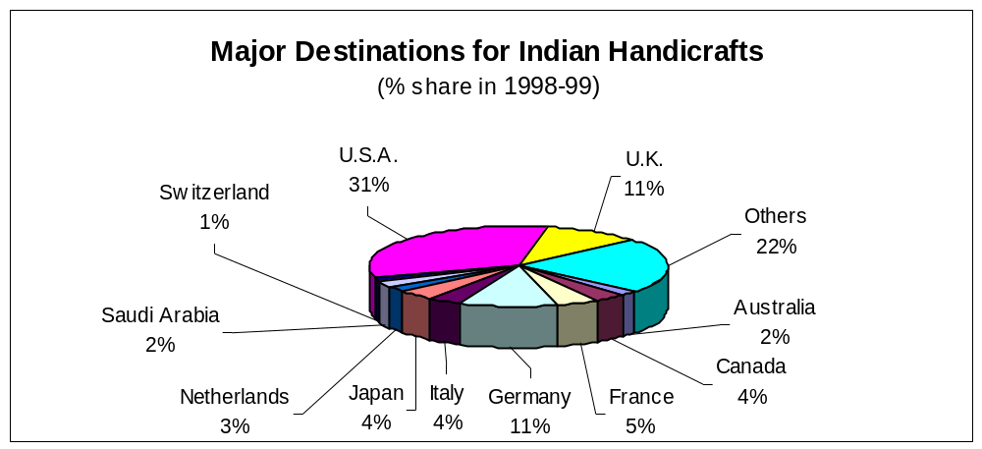

Value Adding Chain in Handicrafts

Identification of market opportunities

Prototype design and development / adaption and refinement

Test marketing

Upgrading equipping facilities

Securing inputs

Entrepreneurial hiring, training, managing

Production, quality control and packaging

Costing and pricing

Physical distribution

Export market development

In the changing world scenario, craft products exported to various countries form a part of lifestyle products in international market. The impact is due to the changing consumer taste and trends. In view of this it is high time that the Indian handicraft industry went into the details of changing designs, patterns, product development, requisite change in production facilities for a variety of materials, production techniques, related expertise to achieve a leadership position in the fast growing competitiveness with other countries.

The 6 million craft persons who are the backbone of Indian Handicraft Industry as provided with inherent skill, technique, traditional craftsmanship but that is quite sufficient for primary platform. However, in changing world market these craft persons need an institutional support, at their places i.e. craft pockets for value addition and for the edge with other competitors like China, Korea, Thailand etc.

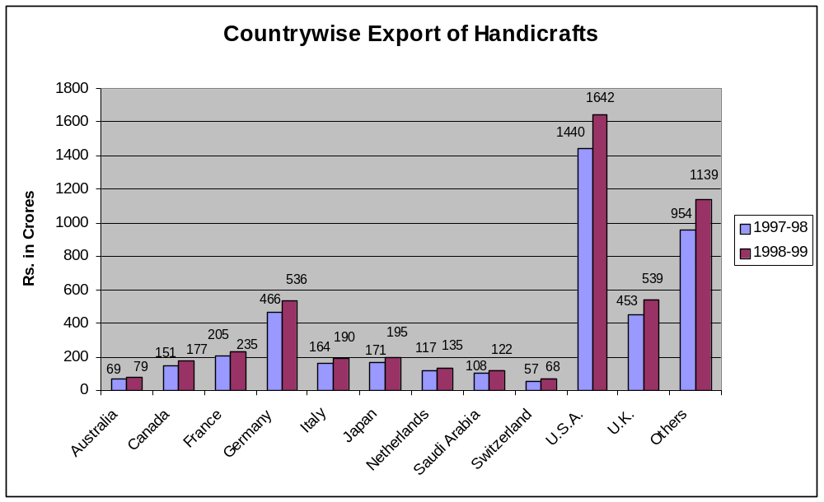

The German handicrafts and Giftware Market

With over 82 million inhabitants, Germany is the largest market for giftware and handicrafts items in Europe. A member of and situated within the European Union, Germany is supplied with giftware and handicrafts from Germany as well as the surrounding European countries such as France, Italy, Switzerland and the United Kingdom and from all other parts of the world: Russia, Latin America, Africa and Asia.

The size of the total German giftware and handicrafts market varies according to the definition of giftware and handicrafts. With its present size around DM 29.5 billion it corresponds to a broad definition of giftware and handicrafts that includes the following items: home furnishings, artmetalware, table accessories, Christmas decoration, woodware and furniture, imitation jewellers, artificial flowers/plants, scents/cosmetics, sweets, toys/computer games, books, discs/videos, watches/jewellery, certain apparel/textile items and others. The German giftware and handicrafts market grew from DM 29.1 billion in 1998 to DM 29.5 billion in 1999, but experienced a slight decline in the first quarter of 2000.

The substantial supply of giftware and handicrafts has transformed the German giftware and handicrafts market into a fiercely price-competitive market place. Nevertheless, innovative and new to market giftware and handicrafts items place still have good market prospects. It is essential for the German giftware and handicrafts marketers to find new products to stay competitive. Although German consumers may be willing to pay a high price for exclusive items they are very price conscious and want value for money. Among traditional gift items, candles, festive items, including Christmas decoration, exclusive gift boxes and gift-wrap, ribbons, nostalgic calendars and all types of scented items have best prospects. The German market shows a strong demand for low-priced candles. Thus imports from Poland and China have increased substantially. The average growth for the overall giftware and handicrafts is estimated at 1-2 percent over 1999-2000.

Competitive Situation

German giftware and handicrafts consumption is growing more or less in line with the relatively slow growth rate of income during the last years. Thus, expectations for additional growth are not very high. Annual growth rates of between 1.5-2 percent are forecast for the next few years for the overall giftware and handicrafts market. In general the market shows good business opportunities if prices and quality are competitive and delivery schedules are fulfilled.

Apart from its own producers, Germany is supplied by giftware and handicrafts from nearly all of the European countries. German firms often import specific product groups from a particular country. Major suppliers of pottery are, for example, Spain and Portugal; fine exclusive stationery comes from Italy, France and Switzerland; candles from Poland, China and Portugal; dried flowers from the Netherlands etc.

Fierce price competition in Germany is intensified by the increasing quantity of Chinese and Asian made products on the market. For India this situation coupled with the relatively strong Indian rupee which means that firms proving to be most successful in the recent past have offered niche market giftware and handicrafts, i.e., exclusive to Indian handicrafts items or new-to-market products.

A few well-established German manufacturers of giftware and handicrafts items are:

Koziol GmbH, Erbach | Krebs-Glas-Lauscha GmbH, Ernstthal
Barti GmbH, Garching | Margarete Steiff GmbH, Giengen
Duni GmbH & Co. KG, Bramsche | WMF AG, Geislingen
Rastal, Hoehr-Grenzhausen | Rosenthal AG, Seib
Fartak, Lahr | W. Goebel Porzellanfabrik, Roedental
GIES Kerzen, Glinde | Walther-Glas GmbH, Bad Driburg
Jet Papier GmbH, Bernau

Sales volume of specific sub-sectors (estimates):

Some estimates of individual giftware and handicrafts subsector volume sales are provided as follows:

Seasonal: Market insiders estimate the total volume of the seasonal items market, including Christmas, Easter, Valentines Day and the German counterpart of Thanksgiving, at DM 7.7 billion. In 1997, about DM 3 billion were spent alone for Christmas decoration, Christmas floristic items and Christmas trees only. Christmas items are usually imported from China, Taiwan, Thailand, Philippines and India. However, Indian Christmas decorations as candle stands or Christmas tree hangings and soft toys find a ready market in Germany if they are moderately priced.

Hobby and art supplies: The present market volume of hobby and art supplies in Germany is estimated at about DM 3 billion, while the total European market should amount to DM 12 billion. Insiders believe that this specific market segment still offers some potential for new products. A recent survey shows that apart from their school days, most of the Germans who do regular DIY or hobby work are between 60 and 69 years (10.8 percent of the German adults) old. With the fast ageing of the German population a stronger demand for hobby and crafts is likely.

Incentive items: From 1992 to 1998, the total German market for incentives increased from nearly DM 3 billion to DM 6 billion.

Toys: In 1998, annual sales of licensing products amounted to about US$ 4.2 billion in Germany. Also in 1998, the toys market volume expanded to DM 6 billion. Total annual sales for computer games and learning games alone, increased to DM 2 billion in 1998 compared to the pre-year level of DM 1.7 billion.

Market Access

EU member states and Asian countries, China and India in particular, are major suppliers of giftware and handicrafts to the German market. Indian firms making a first approach to the German market are advised to have comprehensive product literature and data sheets professionally translated into German. Although English is widely understood, a well-prepared translation gives an important marketing edge, particularly in the initial presentation. Indian firms should preferably appoint an agent or distributor who can maintain a stock sufficient to answer short-notice orders.

Customs Duties

Customs duties vary according to material and product. Though duties are high for a few items, i.e., dried flowers, potpourri (16.7-20 percent), T-shirts (12.0-13.2) and hand- woven, woollen blankets (13.4 percent), the majority of customs duty rates falls in the range of 5-8 percent. For example:
Customs Duties (in percent)

Ceramics | : | 4.1 - 7.5
Toys | : | 5.6 - 6.3
Stationery | : | 8.4
Plush animals | : | 6.0
Quilts/blankets | : | 7.5
Candles | : | 2.8
Silver jewellery | : | 2.5

In addition, there is a 16 percent sales tax, which is eventually passed on to the consumer in form of the value-added tax (VAT). But the VAT has to be paid when entering the German market by the exporter/German importer.

Items that originate from certain animal species, i.e., snakeskin or hides of some animal, it must be ensured that the export of these products complies with the Convention on Endangered Species (CITES). Regarding sample orders, exporters should be aware that one sample with a maximum value of DM 50 each or, five identical samples of one product group not exceeding a total value of DM 50, are usually customs free.

Product Standards

In view of the wide field of products that could be considered as giftware and handicrafts, it is difficult to name standards. Compliance with EU standards and regulations is strongly suggested. There are, however, only few product groups in the giftware and handicrafts field that have to follow standards. It is essential that CE-labelling be observed where required. The CE-mark (including conformity statement and technical documentation) is mainly required for toys (88/378/EEC standard). While the quality regulations for candles are obligatory assuring a certain level of quality, the toy regulation and the electronic standards have to be observed because of safety considerations:

Major Distribution Channels

In Germany, giftware and handicrafts is distributed through five major channels:

Wholesalers
Importers/distributors
Commission agents/sales representatives
Department stores
Mail-order
Internet sales
Tele-shopping

The individual channels are described in detail in the following.

Wholesalers:
Besides offering wide range of goods to retailers for direct sales, this channel also supplies large quantities of individual articles. They are very particular in maintaining consistency in the kind of products and their quality. One of the distinguishing features of wholesalers is to provide distribution and storage facilities. Specialised wholesalers deal in sales to retailers as well as to final consumers. They maintain high quality standards and but have a narrower and in-depth range of arts and crafts.

Importers/distributors:
Most Indian giftware and handicrafts companies use importers/distributors to market and sell their giftware and handicrafts lines. They buy and sell on their own account. Thus, the companies take advantage of the distributor's expertise, his sales force and his existing distribution channels. Distributors call on giftware and handicrafts retailers, purchasing groups and supermarkets. The distributors' mark-up varies depending on the giftware and handicrafts item, but at least 50 percent. While the mark-ups vary according to the distributor; they usually also depend on the exclusivity of a product and on its competitiveness in the overall giftware and handicrafts market.

Germany hosts more than 45,000 giftware and handicrafts retailers. Several retailers import directly from the United States and sell to the German customer. Usually these are small companies looking for items new to the market and handling small orders only.

Commission agents:
Commission agents provide Indian companies with direct access to the German market and direct control. Independent commercial agents are normally working on a 15 percent commission and operate on a regional basis. They concentrate on specialist retailers, purchasing groups and department stores. Commission agent contracts are based on stringent EU and German regulations. An Indian firm wishing to appoint an agent should make sure that such standard contracts meet its expectations. In order to facilitate market entry efforts by the agents their initial commission is often a few percent higher than the "usual" commission. These additional payments are to reimburse the agent for substantial advertising and any special efforts facilitating the new product's market entry.

Department Stores:
Indian companies interested in establishing business contacts with major department stores, mail-order houses and retailers may also choose the direct approach. Department stores in particular, prefer to deal directly with manufacturers. Their buyers are very specialized and only handle a limited range of products. At some occasions department stores also buy through independent commercial agents. Quite often they have their own buyers as well as a few agents that usually work with them and who know their assortments. If a department store decides to import a particular giftware and handicrafts item, it places bulk rather than small orders.

Mail Order:
On an average, each German consumer buys products totaling to DM 500 each year from mail-order houses. There are about 200 mail order companies in Germany. In Europe, Germany is the largest mail order market, followed by Great Britain and France. The total European market volume for mail order products is estimated at approximately DM 90 billion. Of the 20 major mail order companies in Europe, 12 have their headquarters located in Germany. Among them are the world's largest mail order companies: Otto Versand in Hamburg and Quelle Schickedanz AG & Co. in Fuerth. In addition, several German mail order companies operate in other European countries, as well.

Internet Sales:
Germany will become market leader among the EU countries with regard to sales over the Internet by the year 2000. It is anticipated that by then German electronic sales, which are estimated to reach a volume of DM 500 billion worldwide in 2000, become second in the worldwide ranking after the United States and before Japan. A typical German Internet user and a major German mail-order publication is between 20-39 years old, is highly educated and earns more money than the average German consumer. This age group consists of about 4.5 million Germans. Seventy percent of these consumers are male. Already today, the Internet is a major sales channel for German mail-order houses.

Teleshopping:
QVC and HOT are the two tele-shopping channels in Germany. They operate all over Germany and offer various types of giftware and handicrafts; jewellery, fashion, health, beauty; household consumer goods; collectibles and home accessories.

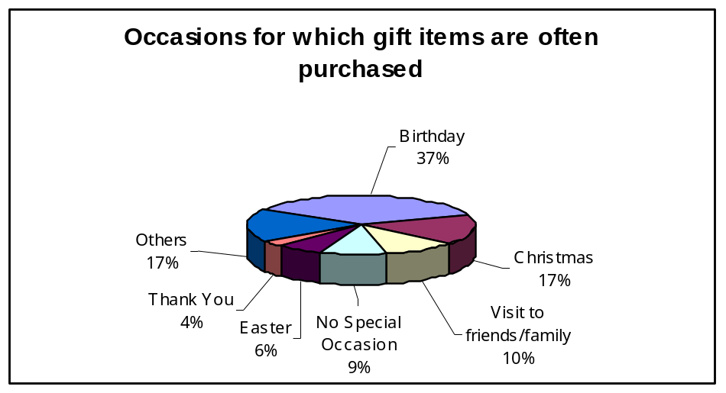

SWOT Analysis of the Indian handicrafts industry

Opportunities  - Rising appreciation for handicrafts by consumers in the developed countries  - Widespread novelty seeking  - Large discretionary income at disposal of consumer from developed countries  - Growth in search made by retail chains in major importing countries for suitable products and reliable suppliers. Opportune for agencies to promote marketing activities  - Use of e-commerce in direct marketing | Strengths  - Abundant and cheap labour hence can compete on price  - Low capital investment and high ratio of value addition  - Aesthetic and functional qualities  - Wrapped in mist of antiquity  - Hand made and hence has few competitors  - Variety of products which are unique  - Exporters willing to handle small orders  - Increasing emphasis on product development and design upgradation  Weaknesses  - Inconsistent quality  - Inadequate market study and marketing strategy  - Lack of adequate infrastructure and communication facilities  - Capacity to handle limited orders  - Untimely delivery schedule  - Unawareness of international standards by many players in the market | Threats  Decline in India’s share  due to:  Better quality products produced by competitors from Europe, South Africa, South Asia, etc.  Better terms of trade by competing countries  Consistent quality and increasing focus on R&D by competing countries  Better packaging  Stricter international standards

